**In Vehicle Coupon Recommendation Project Report**

1. **Problem Statement**

Issuing coupons is a very effective promotional method in many different businesses. However, how and when to issue the coupon is very important. Here, we have an in-vehicle coupon recommendation data set collected from a survey on Amazon Mechanical Turk([source](http://archive.ics.uci.edu/ml/datasets/in-vehicle+coupon+recommendation)). The survey describes different driving scenarios including the destination, current time, weather, passenger, personal information, etc. and then asks the survey takers whether they would accept the coupon from a restaurant, coffee shop, bar etc. if they were the drivers.

Based on the data set, I used different tools in python to clean the data, utilized a variety of exploratory techniques to visualize and analyze the data. Then, I tried many different supervised machine learning models to predict whether a person would use the coupon recommended to him/her in a certain driving scenario.

After training a series of models, I finally tuned a Support Vector Classifier that was able to achieve an accuracy of 92%, which is 12% higher than I expected.

1. **Data Wrangling**

The data set, In Vehicle Coupon Recommendation, has a total 12684 observations and

26 columns, including 25 features and 1 label column representing whether the driver would accept the coupon. Figure 2-1 shows the basic information of the original data set. All features are categorical data in data type object(string) and int64.

In the data set, there were 74 duplicated columns, so I dropped them first. The column ‘car’ has 12576 missing values, which is about 99.1% of the total observations. Therefore, I removed this feature from the data set. Beside, the column ‘Bar’ has 107 missing values; ‘CoffeeHouse’ has 217; ‘CarryAway’ has 151, ‘RestaurantLessThan20’ has 130; ‘Restaurant 20To50’ has 189. The total number of observations with missing values was 4.8%. Since there was enough data for training the models, I dropped all those columns. Based on the description of the data set, the column ‘toCoupon_GEQ5min’ has mean 1.0 and standard deviation 0.0. That means this column only has value 1, so I drop this column. After the data cleaning process, the data set had 12007 observations and 24 columns.

The main tool I used in the Data Wrangling section is pandas.

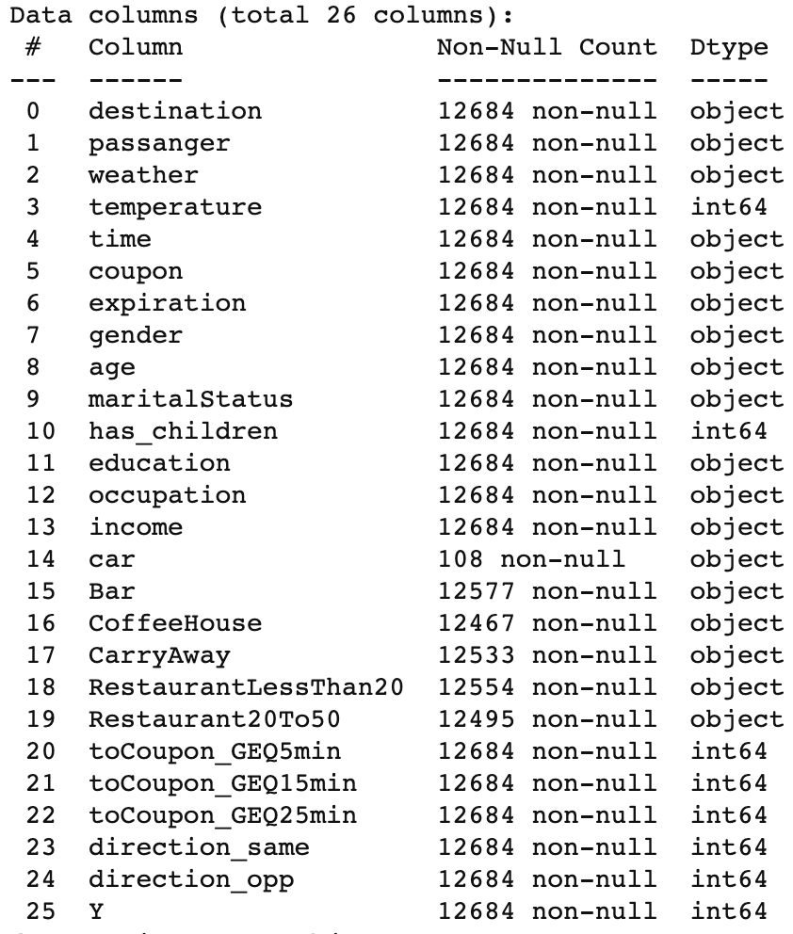

Figure 2-1

1. **Exploratory Data Analysis**

First, I get the statistical information of the data set. Figure3-1 is the table of the statistical data. 57% of the observations accepted the coupon and 43% did not. One interesting fact is that only 11.6% of the drivers would accept if the shop providing a coupon required 25min to drive. The second fact is there may be some mistakes in this data set. The mean of the ‘direction_same’ and the ‘direction_opp’ are 0.22 and 0.78, which are not logical. People should be more likely to accept the coupon that they can use on the way to their destination but not in the opposite direction. But these two features are still if people just labeled them wrong.

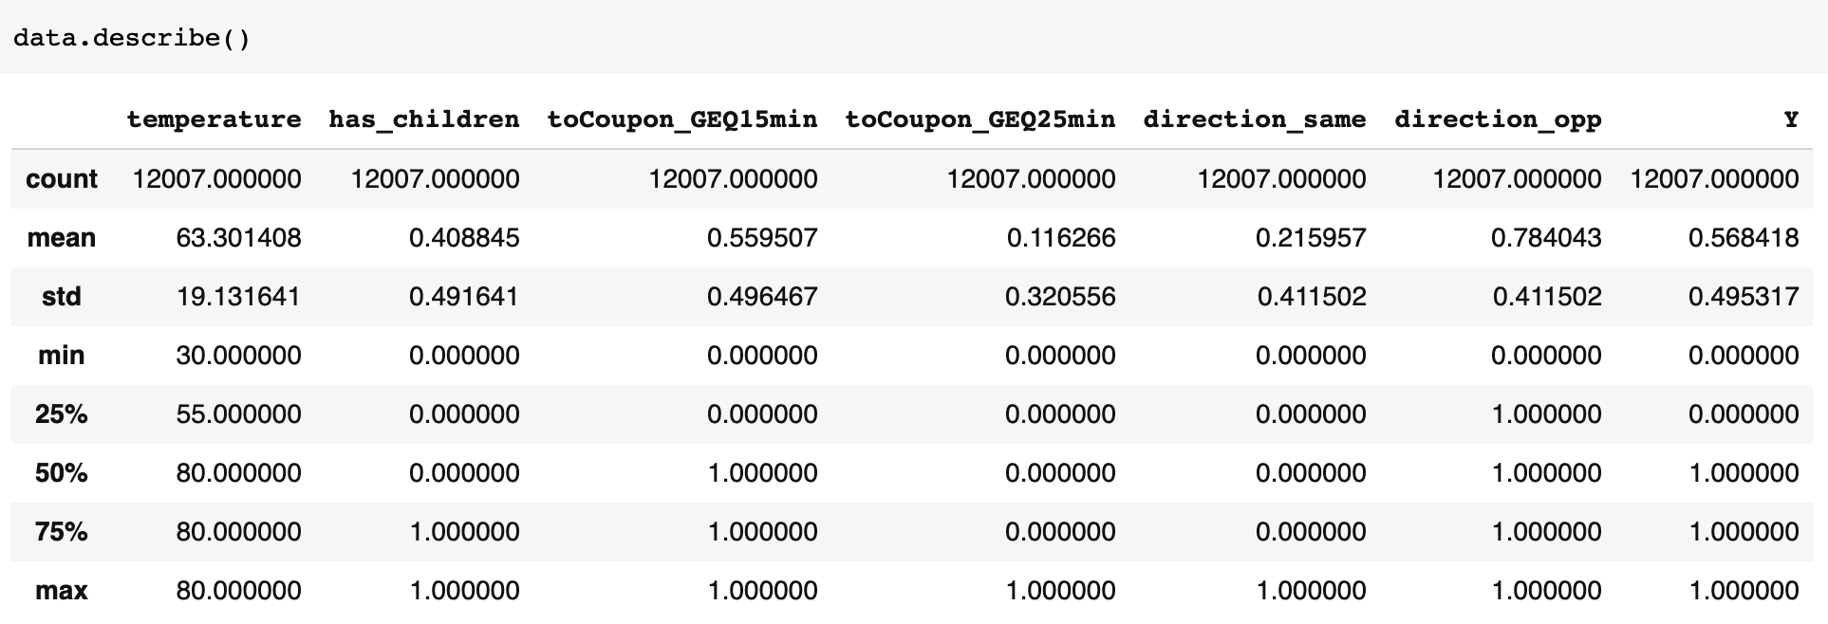

Figure 3-1

Second, I tried a histogram plot to see the distribution of each feature. The interesting fact I found was that the distribution of ‘direction_same’ and the ‘direction_opp’ are the same. See (Figure 3-1) Then I tried a category plot on the ‘direction_same’ feature hue by ‘direction_opp’, and found that all the value 0 in ‘direction_same’ are corresponding to value 1 in ‘direction_opp’ and all the value 1 in ‘direction_same’ are corresponding to value 0 in ‘direction_opp’. This means that these two features are indicating the same thing. (See Figure 3-2) Therefore, I dropped the ‘direction_opp’ column.

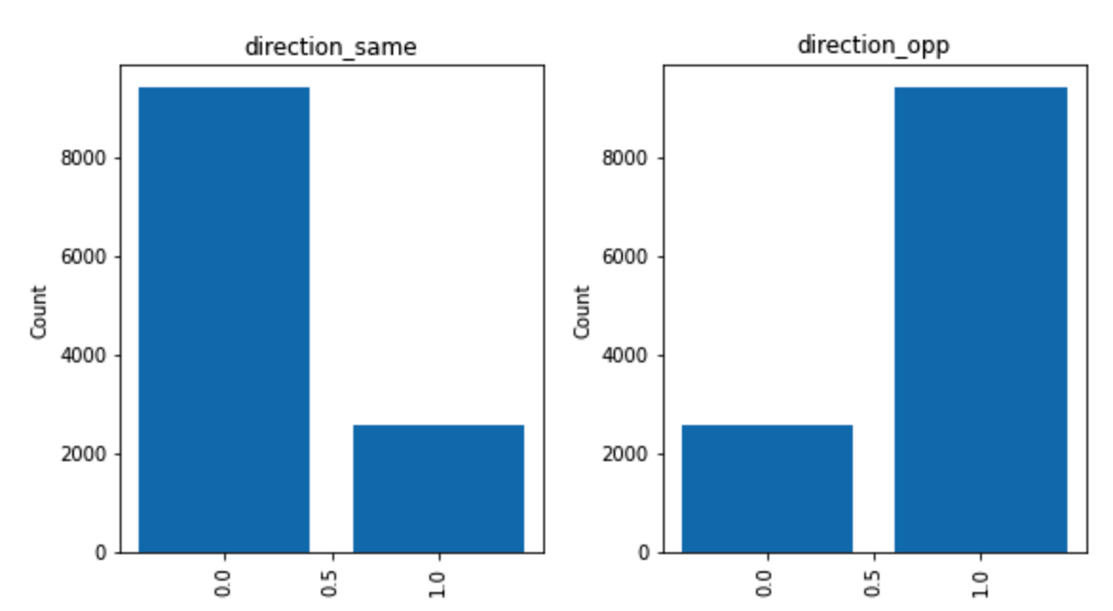Figure 3-1

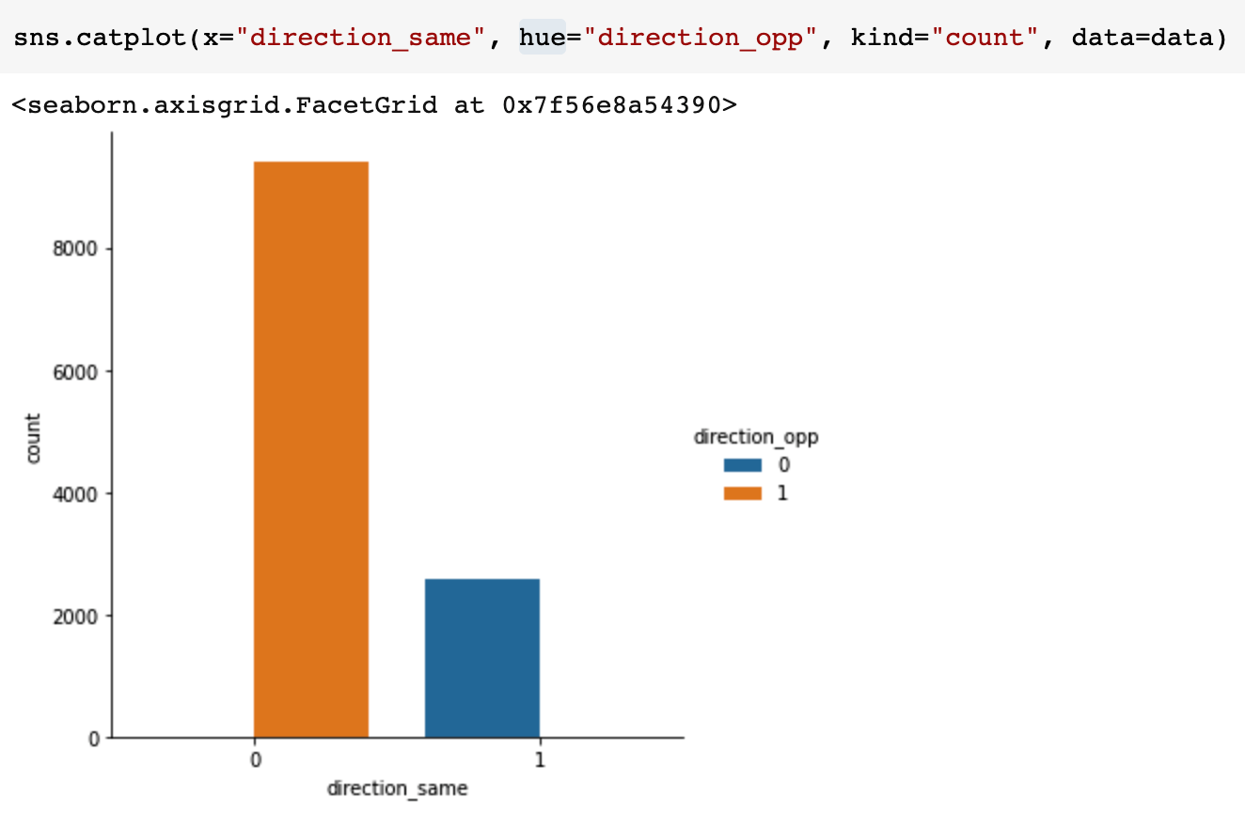

Figure 3-2

Third, I applied count plot on the the data set hue by the label ‘Y’, and found that people more likely accept the coupons when they are going to some not urgent place, or going with their friend, or in sunny day, or in lower temperature, or in the afternoon, or the coupon is less than $20, or coupon is for takeaway, or the coupon expire in a day, or the location is near. Also, People who are younger(< 30 years old), single, and don't have children are more likely to accept the coupons.

After this process, the data set has 12007 observations and 23 columns. The main tools I used in this section are numpy, pandas, seaborn, matplotlib.

1. **Pre-processing & Training Data Development**

Since all the features are in categorical type, I wanted to create dummy variables on all the features using feature engineering technique.

In this section, I created 113 columns from 22 features. The main tools are pandas, numpy.

1. **Model Selection**

In this section, I tested 6 different supervised learning models, including: logistic regression, random forest, k-nearest neighbors, support vector classifier, Naive Bayes, and gradient boosting. To handle the data imbalance problem, I used f1-score as the metrice for the models. To optimize the hyperparameters for each model, I used grid search cross validation.

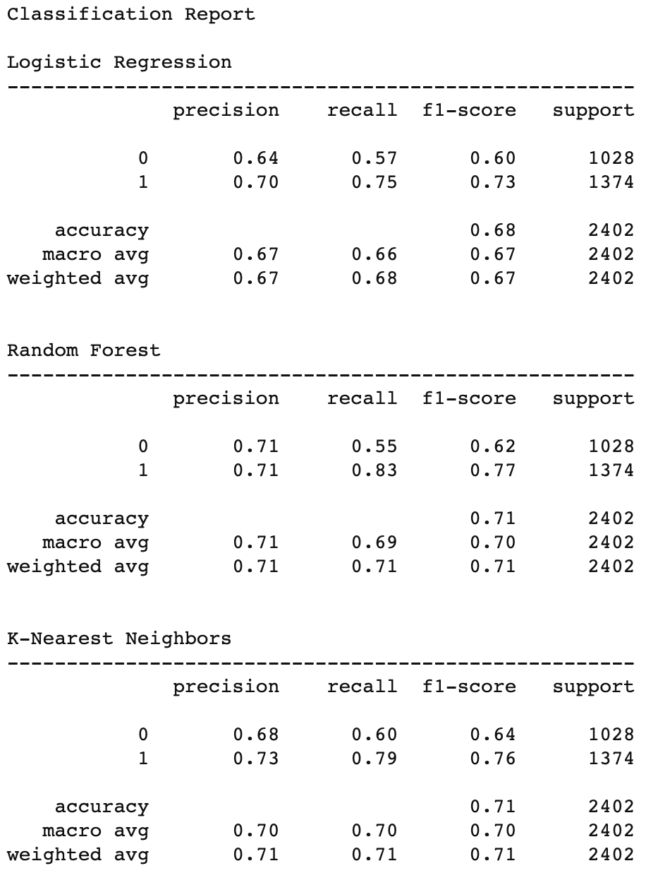

Figure 5-1

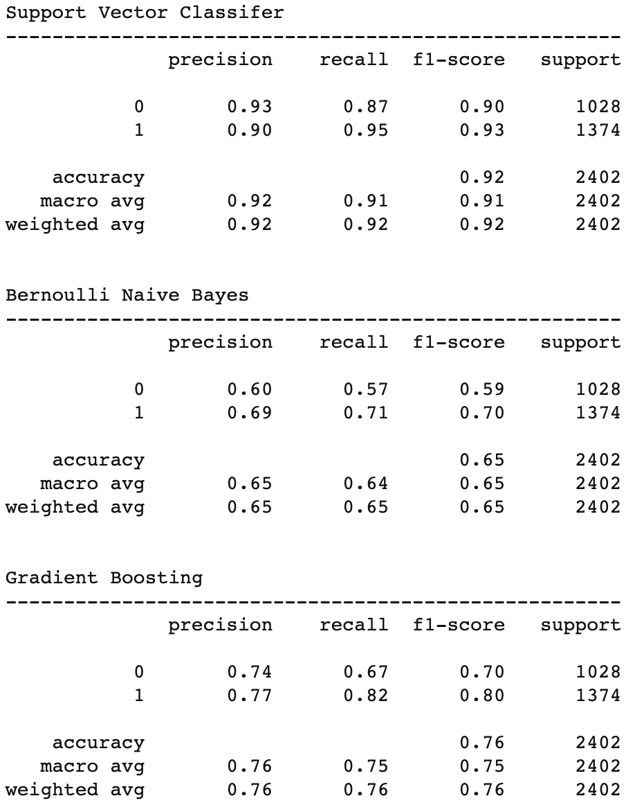

Figure 5-2

Figure 5-1 and Figure 5-2 above are the results of the models using the best hyperparameter set from grid search cross validation. All the models have a higher f1-score on label 1 than babel 0, which means that all of them do better on predicting positive values. Bernoulli Naive Bayes model has the lowest accuracy, which is 0.65. The Random Forest has the lowest recall score on label 0, which is 0.55. This means that it cannot predict the negative item very well.

The Support Vector Classifier model is the best model, it has the highest scores on every metric. The accuracy is 0.92, which is at least 14% higher than other models. Even though the f1-score of label 1 is higher than label 0, they are very close. The Support Vector Classifier model does the best on optimizing true negatives compared to the five other models. Therefore, my final models will be the Support Vector Classifier model. The optimized hyperparameters from grid search are gamma='scale',kernel='poly'.

The main tools I used in the model selection section are pandas, numpy, skiearn.

1. **Final Thought**

About this project, I have two ideas for further improvement and research.

First, since this survey is for general catering business, I think the researchers can also ask people their food and drink preferences. It is important because for most of the time, people are more interested in what is on sale but not how much discount.

Second, I think a similar research can be applied to customers in a big shopping mall. There is no doubt that by learning the behavior of the customers can help increase the revenue. The survey takers are more easy to get in the shopping mall because they are more free. Last but not least, the survey would be more accurate or less noisy since people in the shopping mall are the exact target population.